Supplementary Information
exSEEK: a computational tool of exRNA biomarker detection for liquid biopsy

Supplementary Figures 1
Supplementary figure 1 |
Supplementary figure 2 |
Supplementary Notes
Supplementary Note 1 | Illustration of variance score, b and w
Supplementary Note 2 | Technical notes on variance explained
Supplementary References

Supplementary Figures
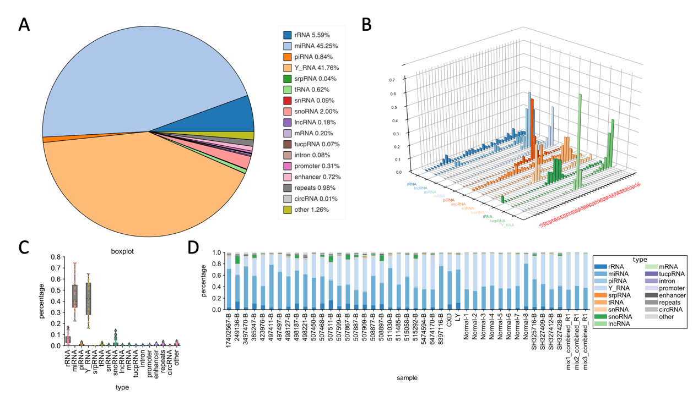

Supplementary figure 1 | Summary of S-cfRNA-seq data mapping
Some summary plot of dataset GSE123973 (A) Pie plot of different RNA mapping ratios; (B) Length distribution of different RNAs; (C) Box plot of different RNAs mapping ratio; (D) Stack bar plot of each samples’ different RNAs’ mapping ratio.
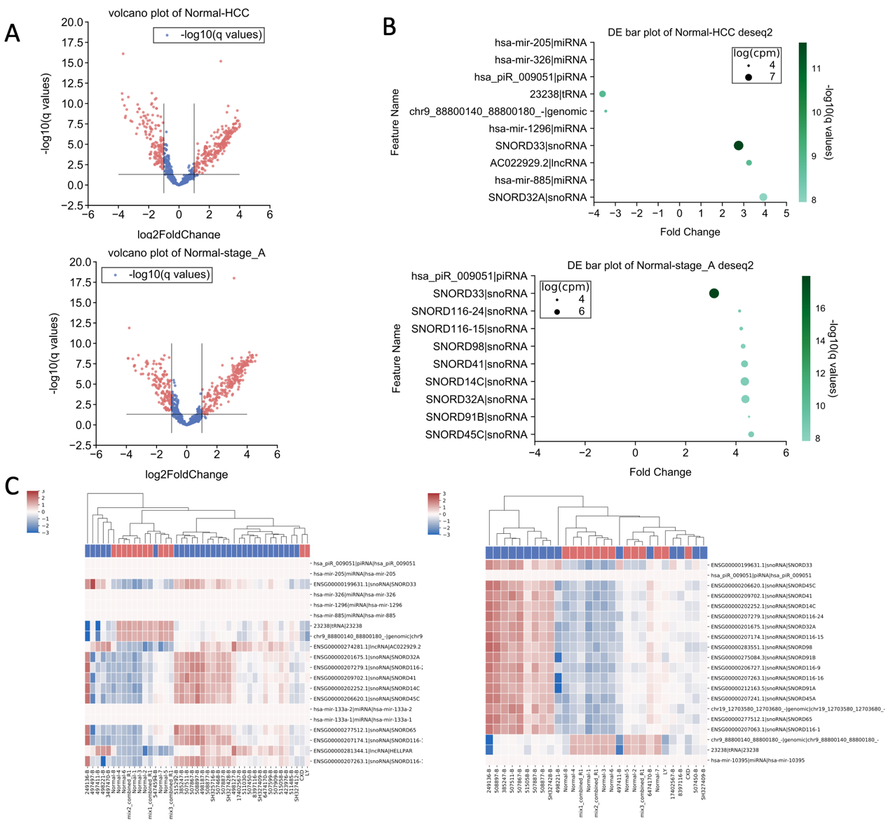

Supplementary figure 2 | Summary of S-cfRNA-seq data differential expression analysis
We did differential analysis on dataset GSE123973 for cancer HCC and HCC stage 1 with healthy control. (A) Volcano plot of each genes’ log2 fold change and -log10 adjusted p value; (B) Top 10 differentially expressed genes’ fold change, expression value (in log CPM) and their’ -log10 adjusted p value; (C) Clustermap of top differentially expressed genes to show their ability to classify cancers from healthy control samples.

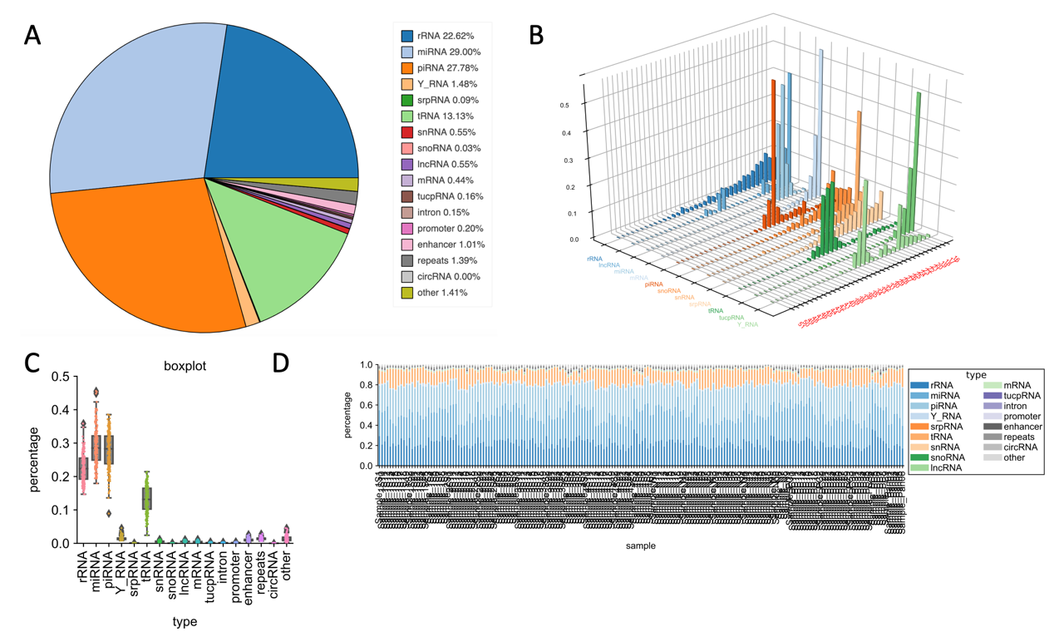

Supplementary figure 3 | Summary of S-exoRNA-seq data mapping
Some summary plot of dataset GSE71008. (A) Pie plot of different RNA mapping ratios; (B) Length distribution of different RNAs; (C) Box plot of different RNAs mapping ratio; (D) Stack bar plot of each samples’ different RNAs’ mapping ratio.

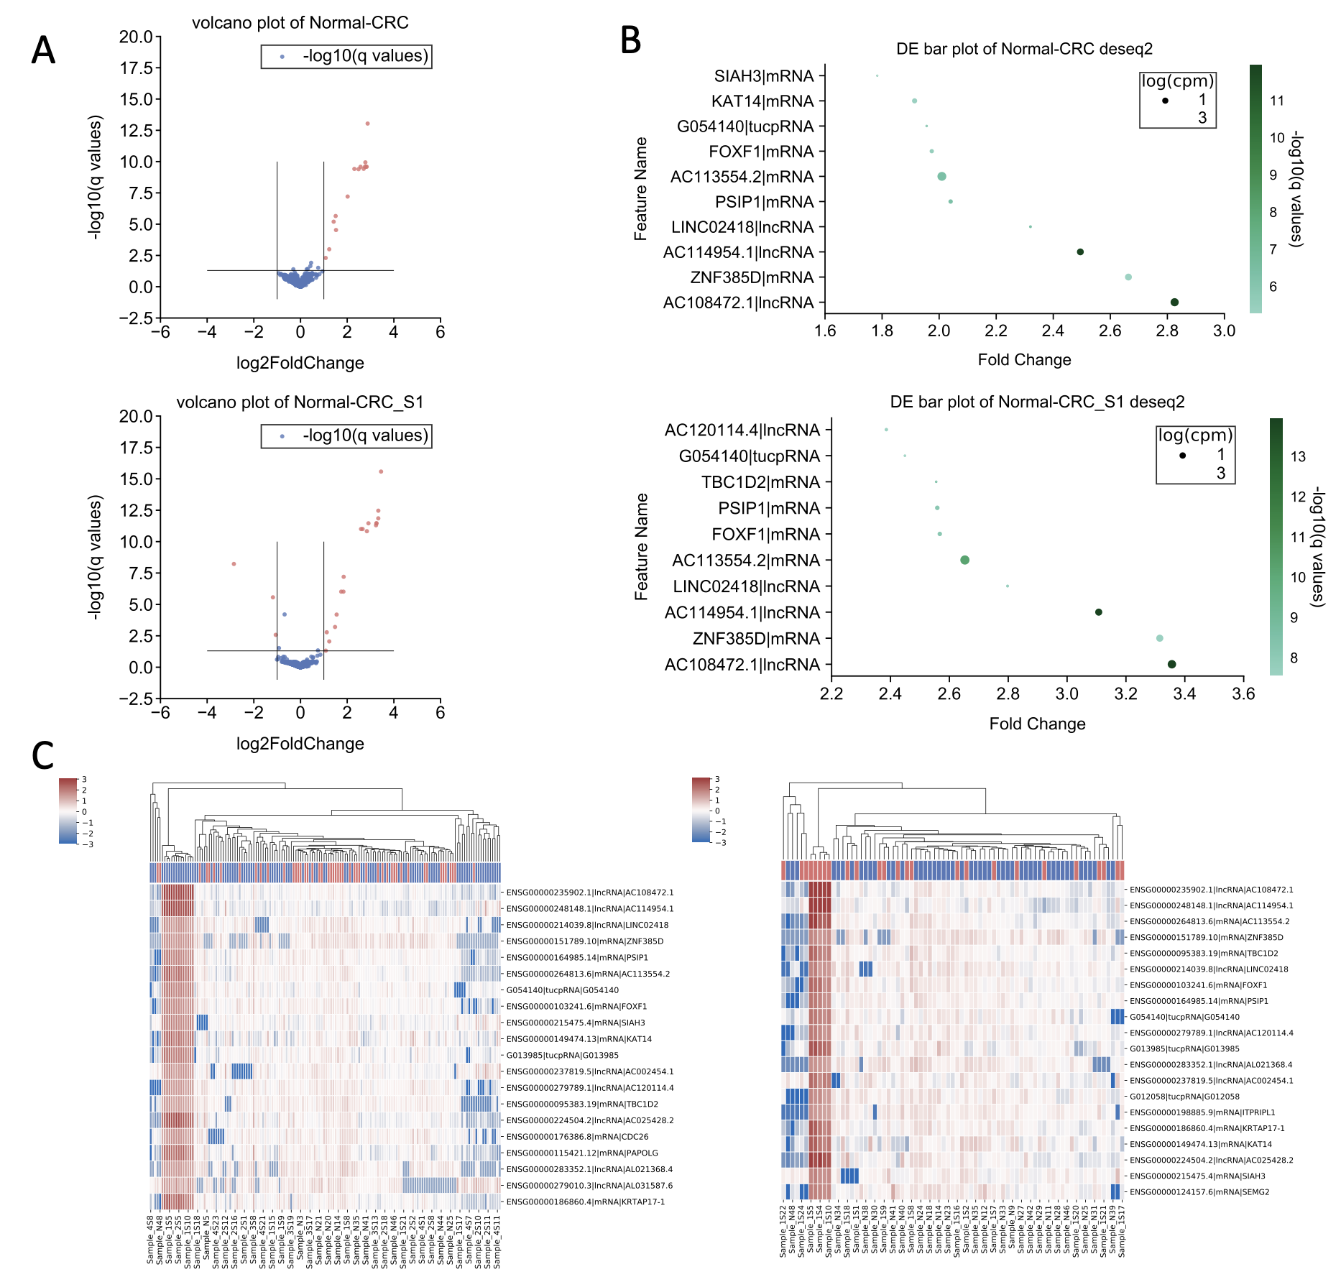

Supplementary figure 4 | Summary of S-exoRNA-seq data differential expression analysis
We did differential analysis on dataset GSE71008 for cancer CRC and CRC stage 1 with healthy control. (A) Volcano plot of each genes’ log2 fold change and -log10 adjusted p value; (B) Top 10 differentially expressed genes’ fold change, expression value (in log CPM) and their’ -log10 adjusted p value; (C) Clustermap of top differentially expressed genes to show their ability to classify cancers from healthy control samples.

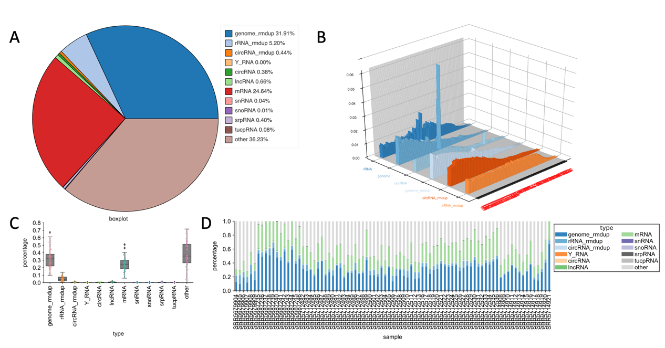

Supplementary figure 5 | Summary of L-exoRNA-seq data mapping
Some summary plot of dataset exoRBase. (A) Pie plot of different RNA mapping ratios; (B) Length distribution of different RNAs; (C) Box plot of different RNAs mapping ratio; (D) Stack bar plot of each samples’ different RNAs’ mapping ratio.

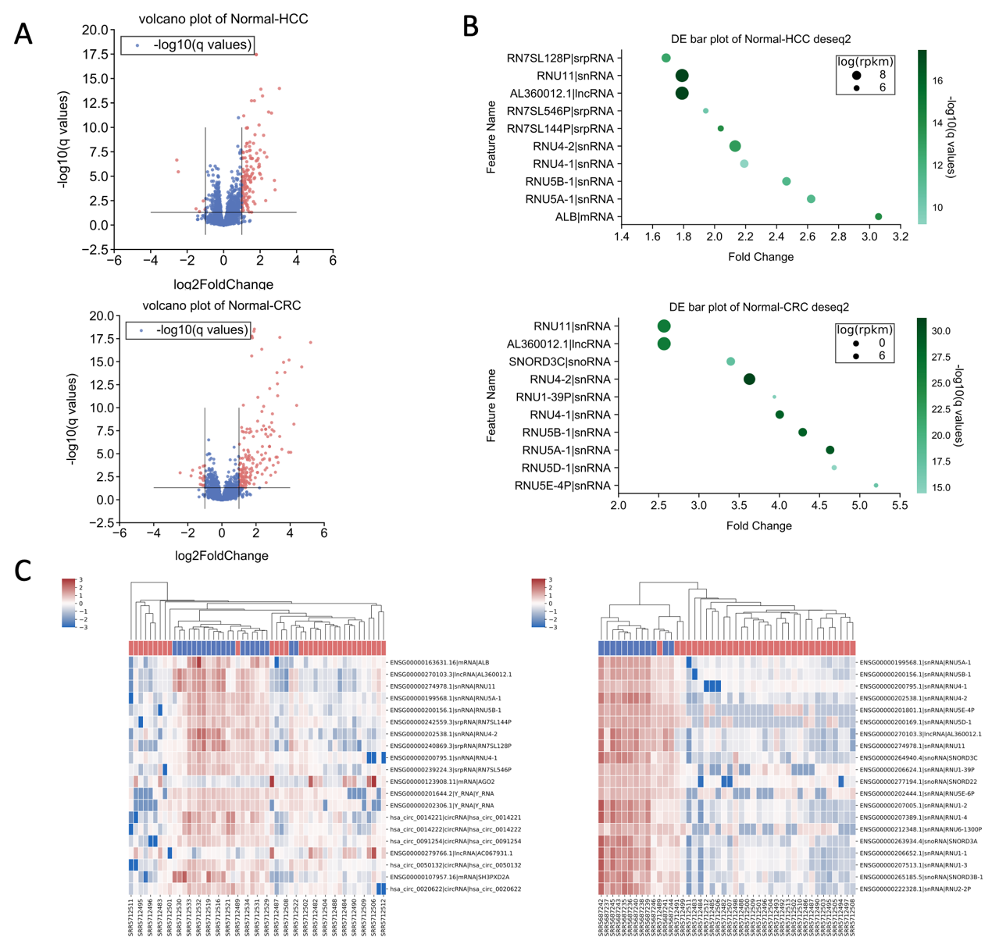

Supplementary figure 6 | Summary of L-exoRNA-seq data differential expression analysis
We did differential analysis on dataset exoRBase for cancer HCC and CRC with healthy control. (A) Volcano plot of each genes’ log2 fold change and -log10 adjusted p value; (B) Top 10 differentially expressed genes’ fold change, expression value (in log RPKM) and their’ -log10 adjusted p value; (C) Clustermap of top differentially expressed genes to show their ability to classify cancers from healthy control samples.

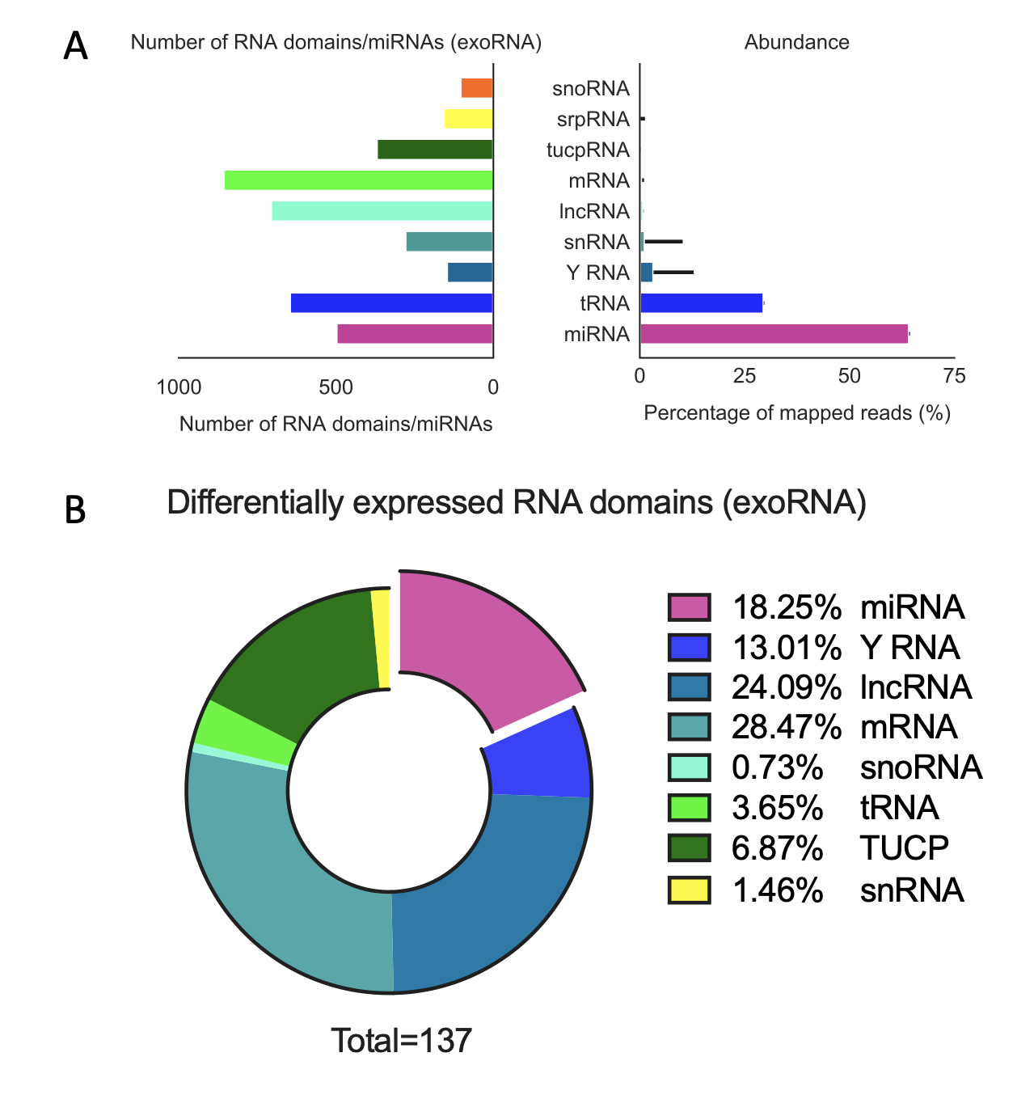

Supplementary figure 7 | Summary of exoRNA dataset domains and miRNAs abundance and diversity
(A) abundance and diversity of exoRNA dataset domains and miRNAs. miRNA accounts for most of mapped reads.
(B) Differentially expressed RNA domains. Most of them are miRNA, lncRNA and mRNA. The total differentially expressed RNA amount is small.

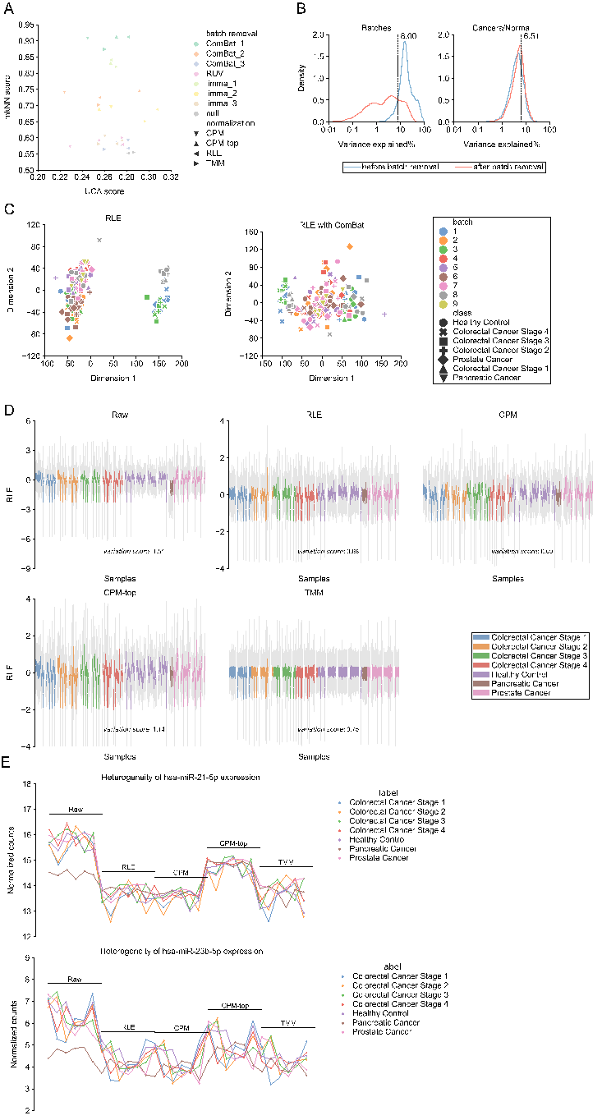

Supplementary figure 8 | Normalization and batch correction of dataset GSE71008
- For dataset GSE71008, we accessed the UCA and mkNN scores of every count matrix undergoing various joint processes of normalization and batch removal. Joint process of RLE followed by ComBat has the best performance. 1, 2, and 3 in legend means there are three kinds batches, RNA isolation batch, library preparation day and gel cut size selection, respectively.
B) Kdeplot matrix of genes’ abilities in explaining batch or biological variance for (RLE)-normalized and (RLE with limma)-normalized count matrix. Fewer significant genes explain batch variance after batch removal (the red line moves to the left relative to the blue line in the left side), and a similar number of significant genes explain biological variance (the red line doesn’t almost move to the left relative to the blue line in the right side). Detailed information about variance explained is in Supplementary Note 2.
C) Scatterplot matrix of first two principal components (PCs) for (RLE)-normalized and (RLE with ComBat)-normalized count matrix. Shapes represent biological difference. ComBat removes batch (RNA isolation batch) effect (the samples no longer cluster by color after undergoing ComBat normalization).
D) RLEplot matrices before and after undergoing RLE normalization. The variant scores depict the variance among samples. Detailed information about variant score is in Supplementary Note 1.
E) Counts heterogeneity plot among samples between or within datasets. We chose stably expressed genes hsa-miR-21-5p and hsa-miR-23b-5p instead of all genes to calculate heterogeneity. RLE reduces heterogeneity (the two lines are flatter and closer).

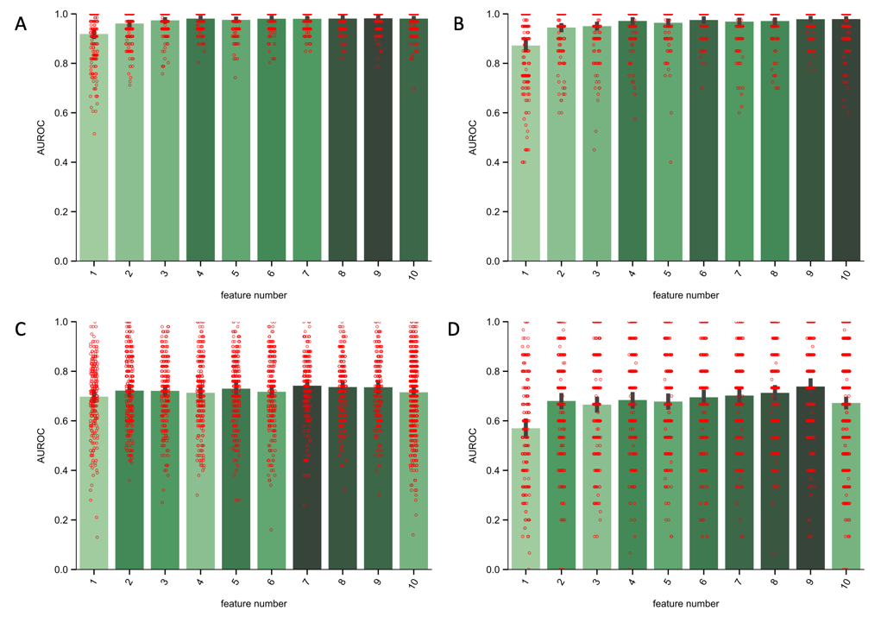

Supplementary figure 11 | Number of selected features
We observed that in different dataset and for different cancer stages, the AUC of different number of selected features varies only a little. It is possible to select less than 5 features to have a good classification performance. (A) HCC in dataset GSE123973; (B) HCC stage 1 in dataset GSE123973; (C) CRC in dataset GSE7100; (D) CRC stage 1 in dataset GSE7100.

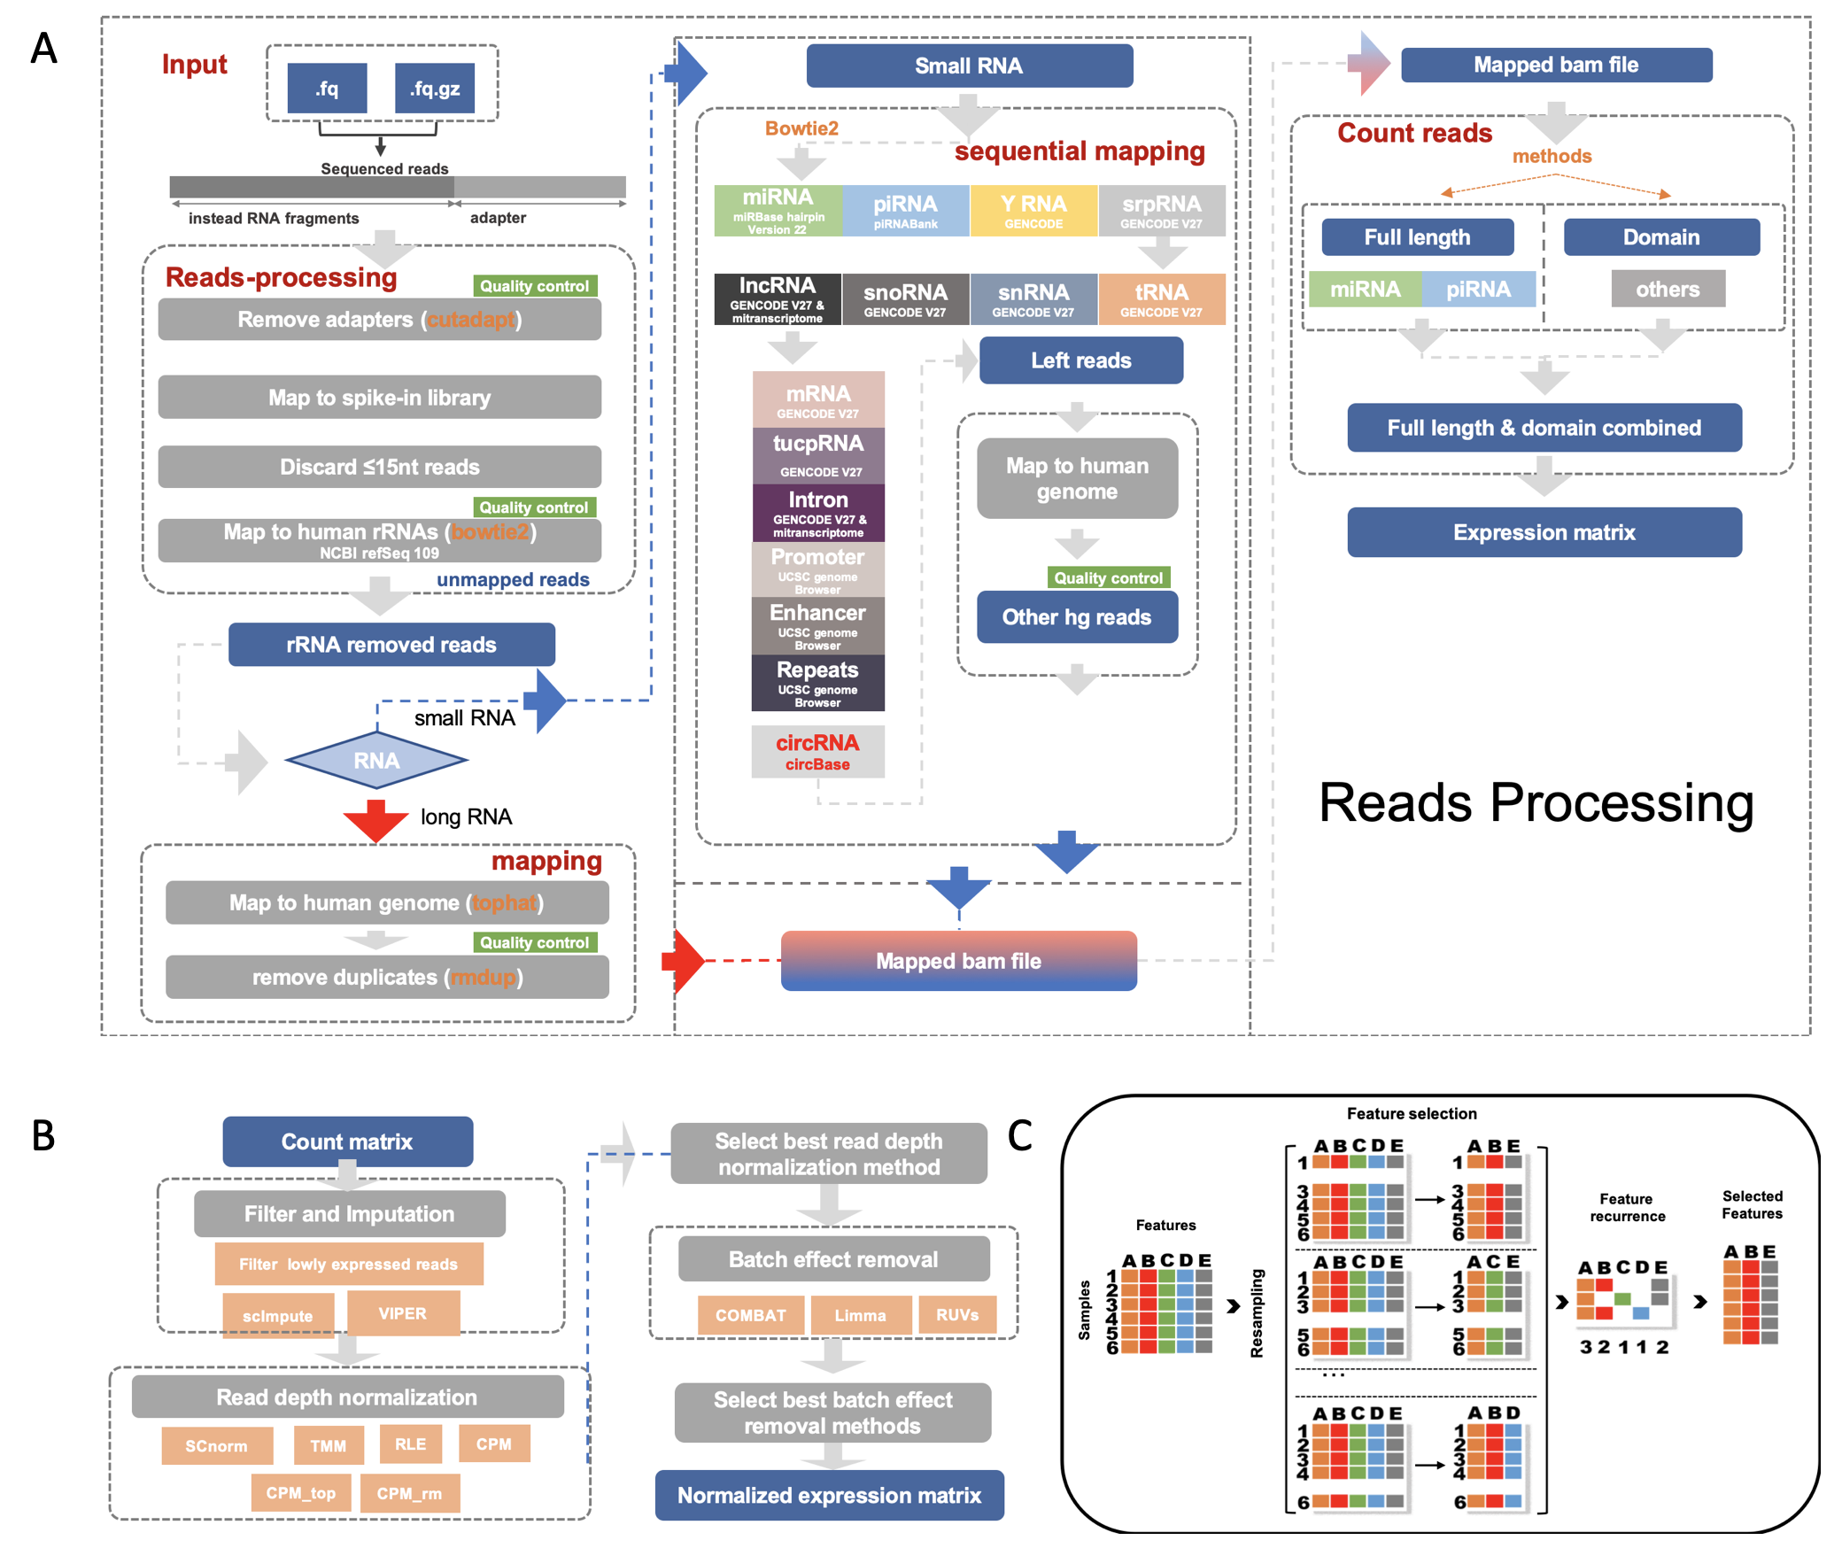

Supplementary figure 12 | Reads processing, matrix processing and feature selection pipeline.
(A) Reads processing pipeline with reads cleaning, quality control, sequential mapping, domain calling.
(B) Matrix processing including imputation, normalization, batch correction.
(C) One of the feature selection strategy we use, resampling 50 times to select recurrently appeared features as robust candidates.

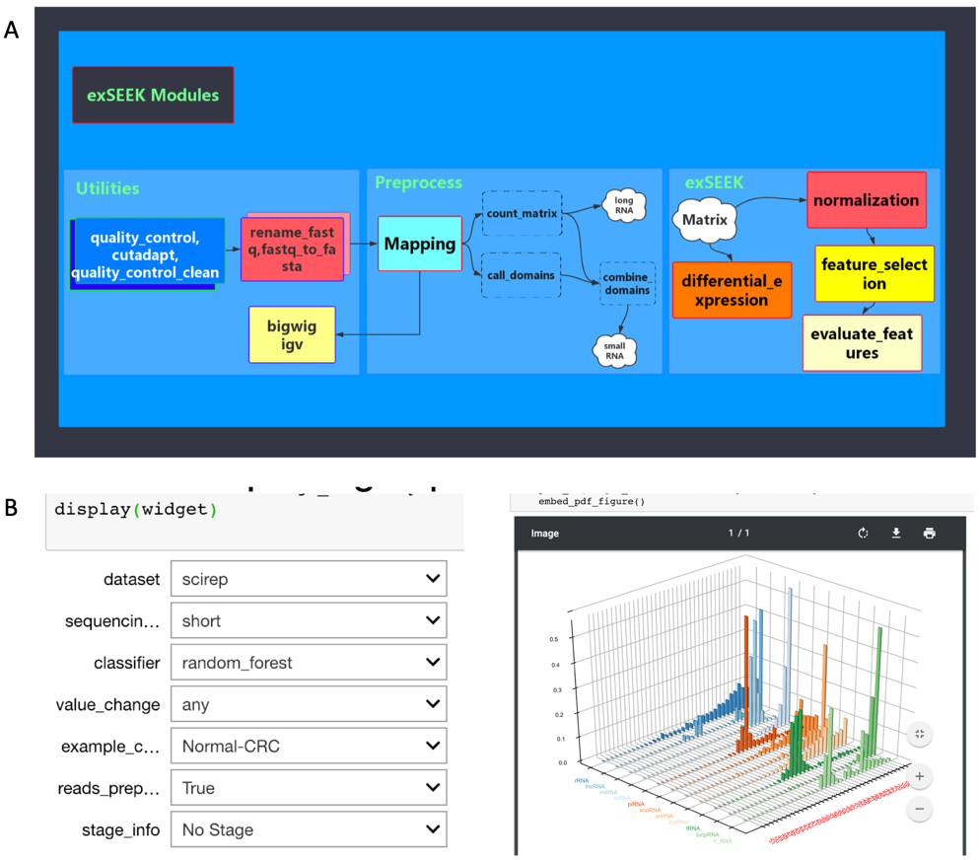

Supplementary figure 13 | exSEEK modules and plotting environment
(A) exSEEK has three main modules which can be run sequentially or separately.
(B) exSEEK use jupyter notebook for users to interactively generates high standards plots of exSEEK output.

Supplementary Notes

Supplementary Note 1 | Illustration of variance score, $b$ and $w$
To reveal differences among samples in RLEplot, we define variation score as below:
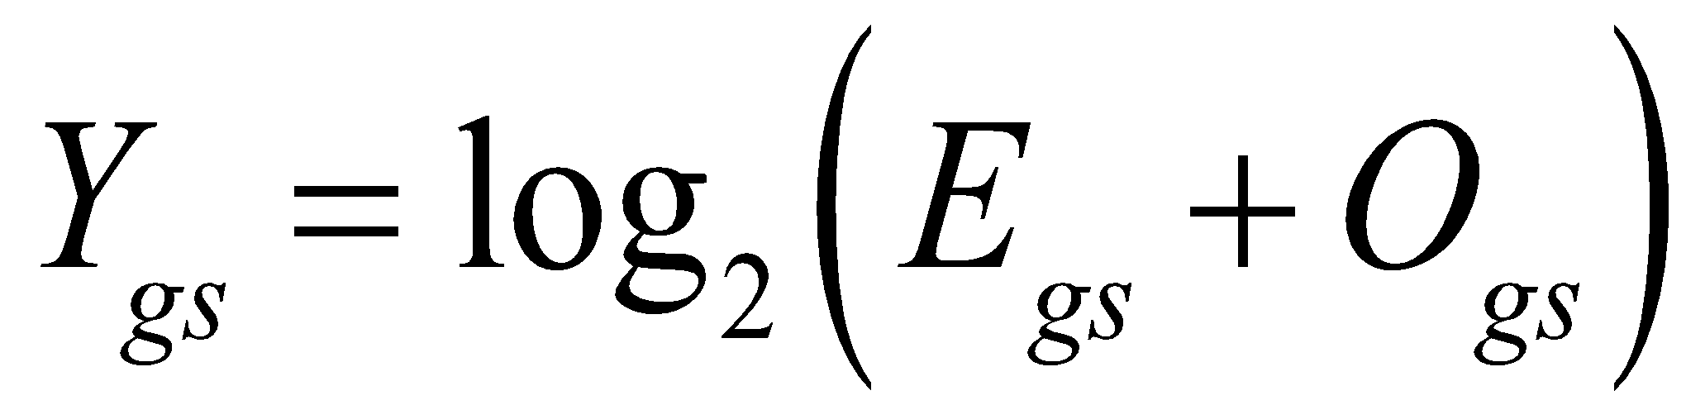
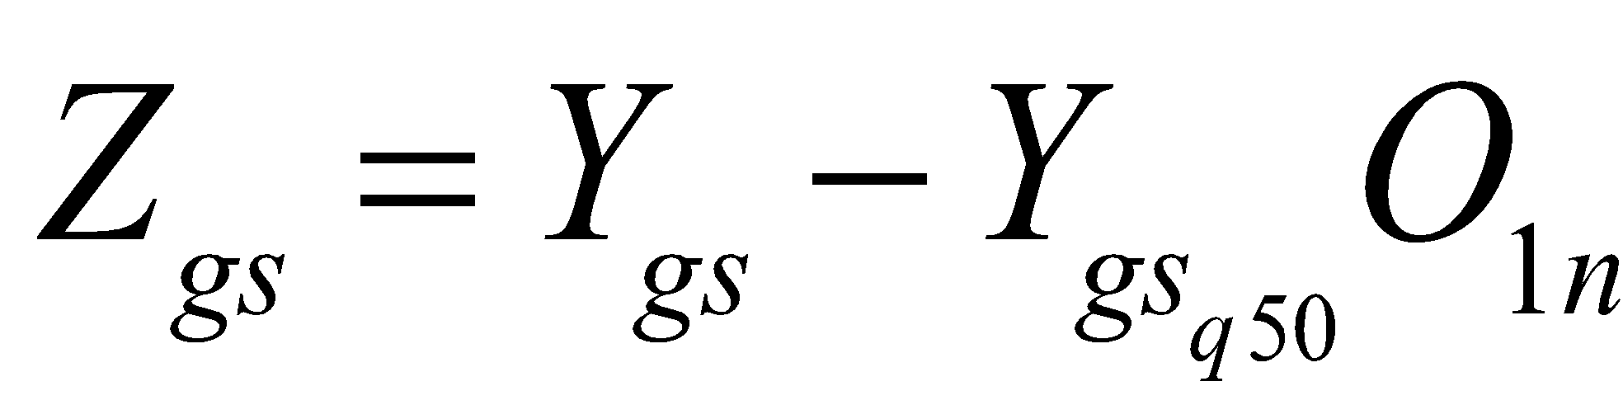
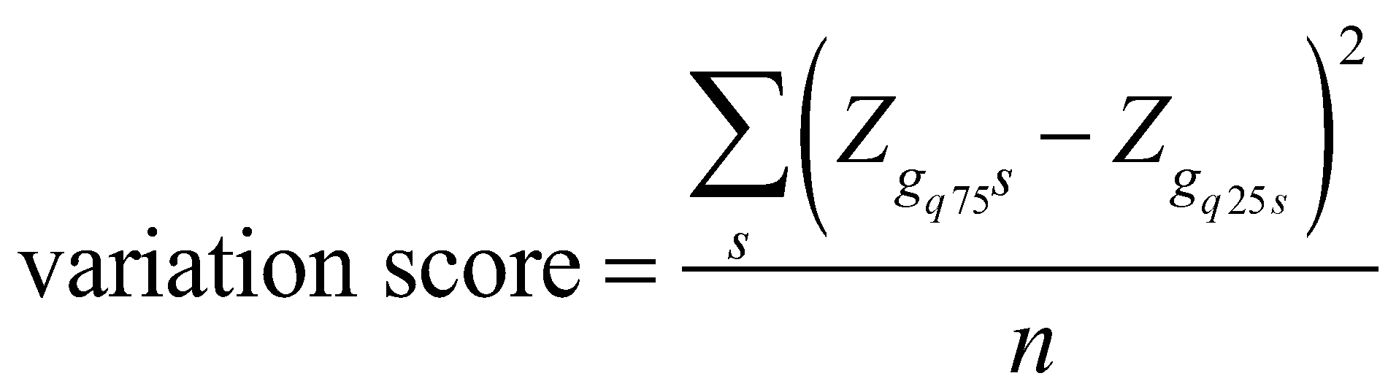
where  , , and are the expression matrix( and represents gene and sample respectively) , a matrix filled with one with the same number of rows and columns as , number of samples, and q-th quantile of a row or column of standardized matrices(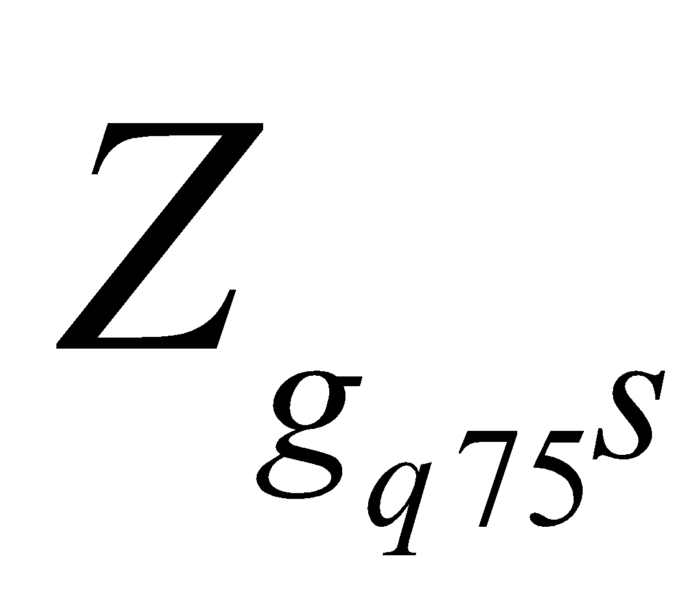 represents 75-th quantile of normalized counts of genes for each sample column), respectively.

To reveal the heterogeneity between and within datasets, we define $b$ and $w$ respectively as below:
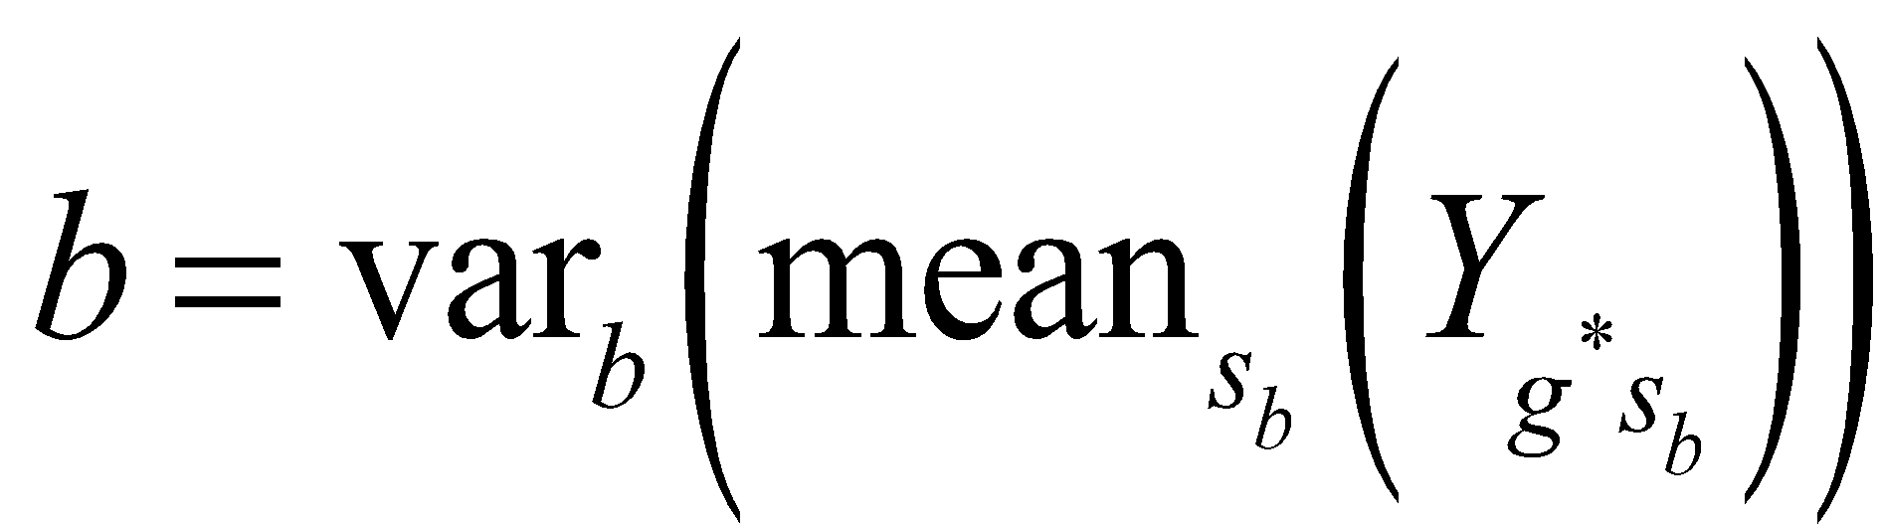
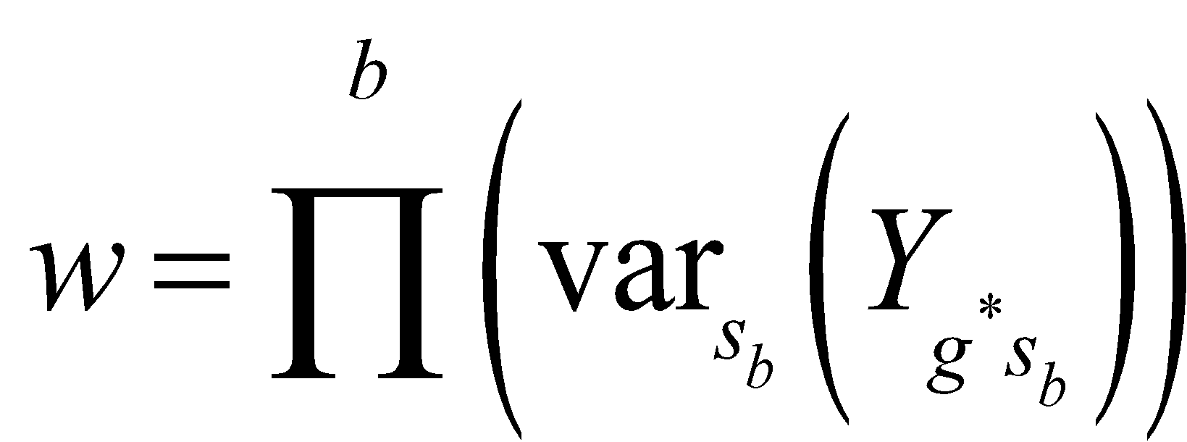
where 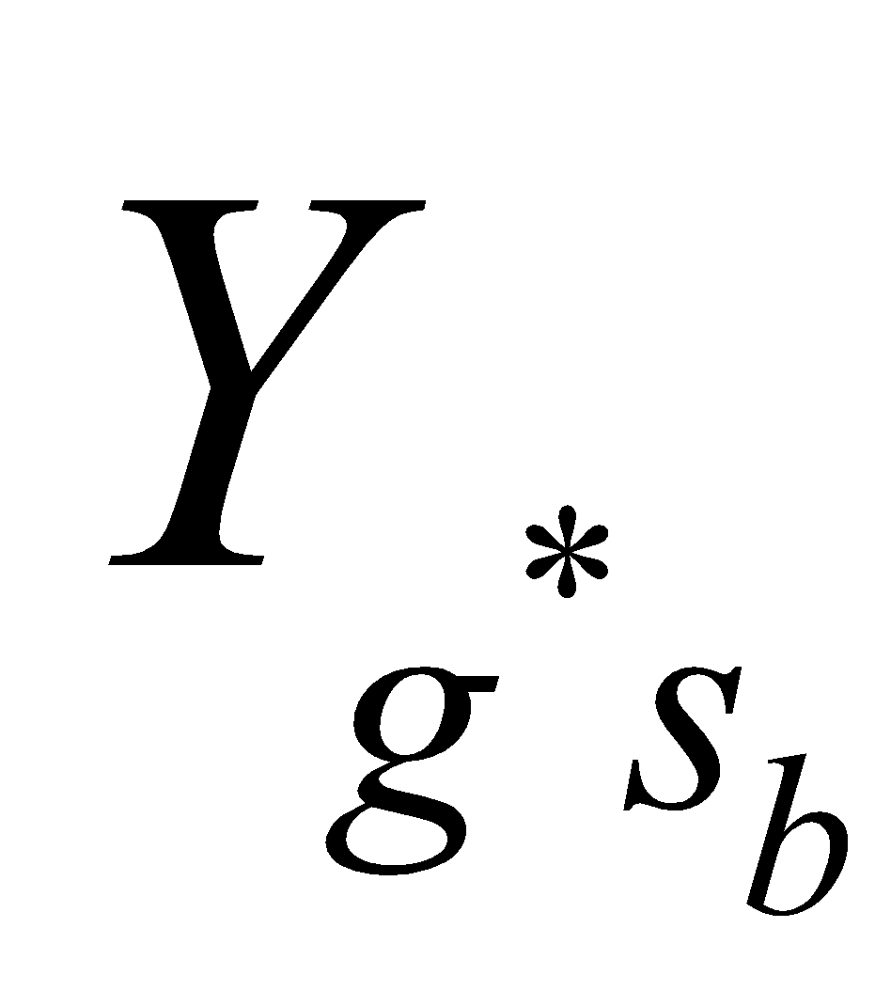is the expression matrix( and  represent reference genes expressed stably and samples sorted by batches respectively) and  is batch.

Supplementary Note 2 | Technical notes on variance explained

Horizontal axis of Supplementary figure 2B, ‘variance explain%’ is a statistic depicts the ability of a category classifies a list which is the foundation of One-Way ANOVA. We have the expression matrix ( and represent genes and samples sorted by categories such as batches or biological classes). For each gene, class and sample, we have the expression value 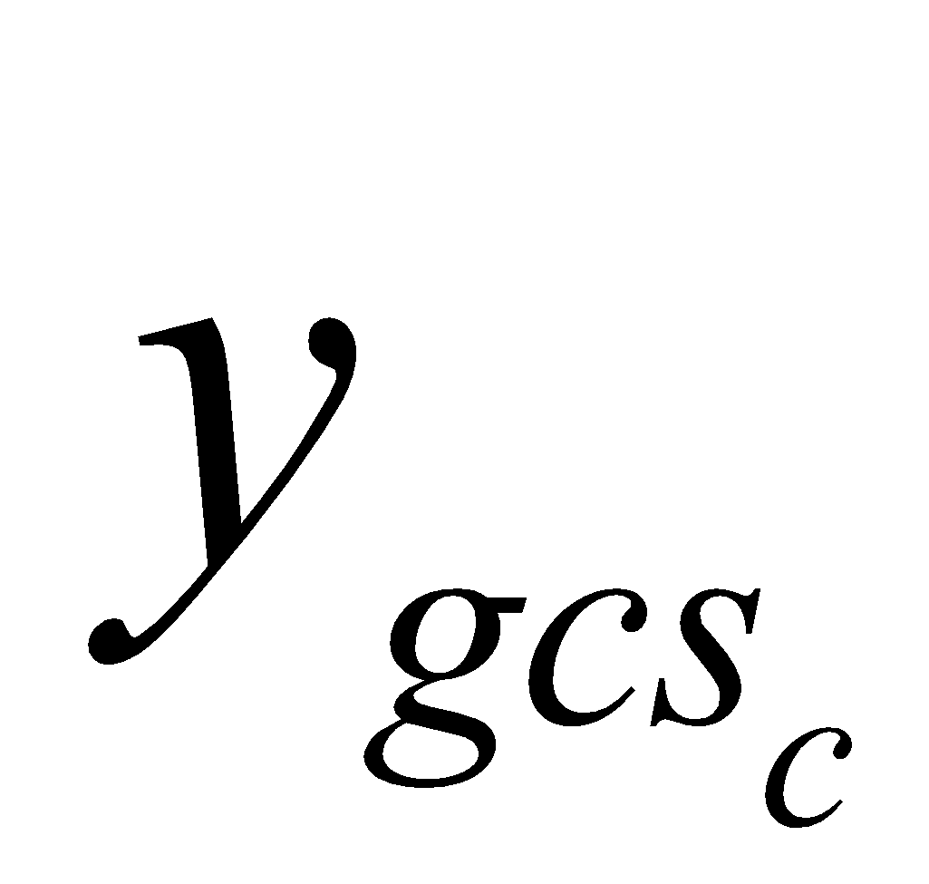. ‘variance explain%’ can be calculated as:
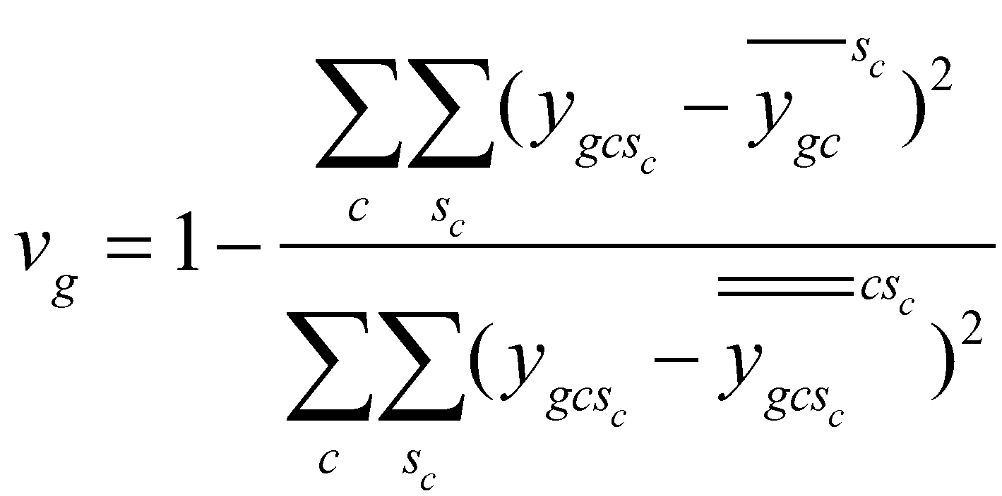
We can test the hypothesis 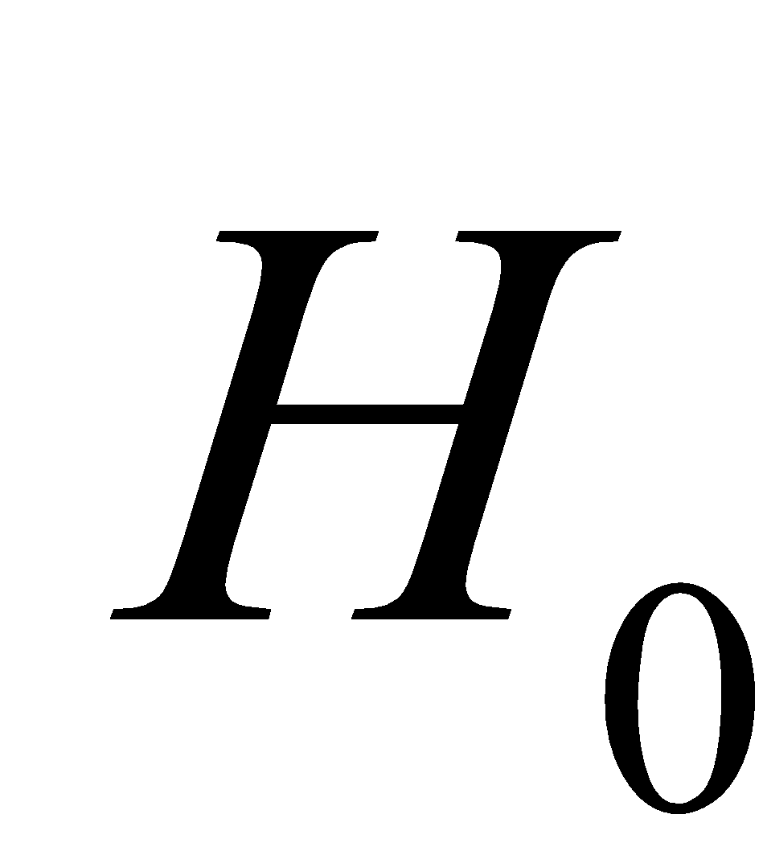: the category can’t sort samples
If the statistic 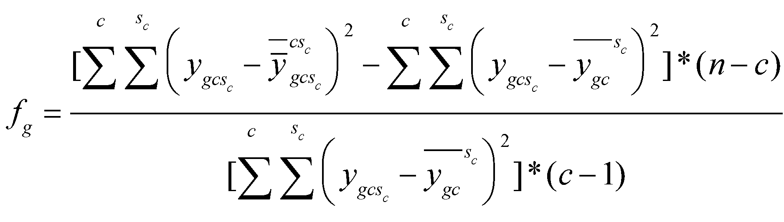 is large, then we reject , that is, if 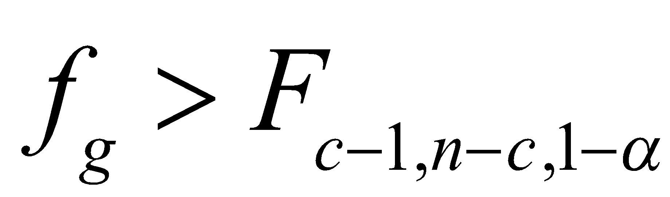 then reject

Supplementary References

- Butler, A., Hoffman, P., Smibert, P., Papalexi, E., and Satija, R. (2018). Integrating single-cell transcriptomic data across different conditions, technologies, and species. Nat Biotechnol 36, 411-+.
- Lazar, C., Meganck, S., Taminau, J., Steenhoff, D., Coletta, A., Molter, C., Weiss-Solis, D.Y., Duque, R., Bersini, H., and Nowe, A. (2013). Batch effect removal methods for microarray gene expression data integration: a survey. Brief Bioinform 14, 469-490.
- Lopez, R., Regier, J., Cole, M.B., Jordan, M.I., and Yosef, N. (2018). Deep generative modeling for single-cell transcriptomics. Nat Methods 15, 1053-+.

